**Quadratic Equation**

**CODE:**

#include <iostream>

#include <cmath>

using namespace std;

int main()

{

float a, b, c, x1, x2, discriminant, realPart, imaginaryPart;

cout << "Enter coefficients a, b and c: ";

cin >> a >> b >> c;

discriminant = b * b - 4 * a * c;

if (discriminant > 0)

{

x1 = (-b + sqrt(discriminant)) / (2 * a);

x2 = (-b - sqrt(discriminant)) / (2 * a);

cout << "Roots are real and different." << endl;

cout << "x1 = " << x1 << endl;

cout << "x2 = " << x2 << endl;

}

else if (discriminant == 0)

{

cout << "Roots are real and same." << endl;

x1 = -b / (2 * a);

cout << "x1 = x2 =" << x1 << endl;

}

else

{

realPart = -b / (2 * a);

imaginaryPart = sqrt(-discriminant) / (2 * a);

cout << "Roots are complex and different." << endl;

cout << "x1 = " << realPart << "+" << imaginaryPart << "i" << endl;

cout << "x2 = " << realPart << "-" << imaginaryPart << "i" << endl;

}

return 0;

}

**OUTPUT:**

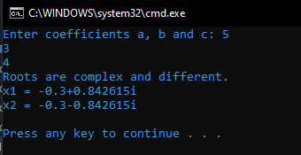

**Operators Precedence in C++**

**CODE:**

#include <iostream>

using namespace std;

int main() {

int a = 20;

int b = 10;

int c = 15;

int d = 5;

int e;

e = (a + b) * c / d;

cout << "Value of (a + b) * c / d is :" << e << endl ;

e = ((a + b) * c) / d;

cout << "Value of ((a + b) * c) / d is :" << e << endl ;

e = (a + b) * (c / d);

cout << "Value of (a + b) * (c / d) is :" << e << endl ;

e = a + (b * c) / d;

cout << "Value of a + (b * c) / d is :" << e << endl ;

return 0;

}

**OUTPUT:**

